IMAGES | The Western Gulf Peoples
Coahuiltecan | Karankawa

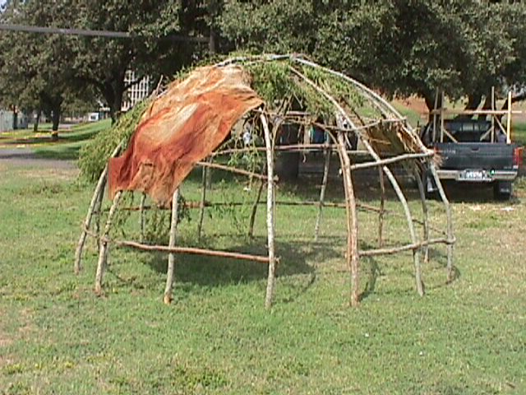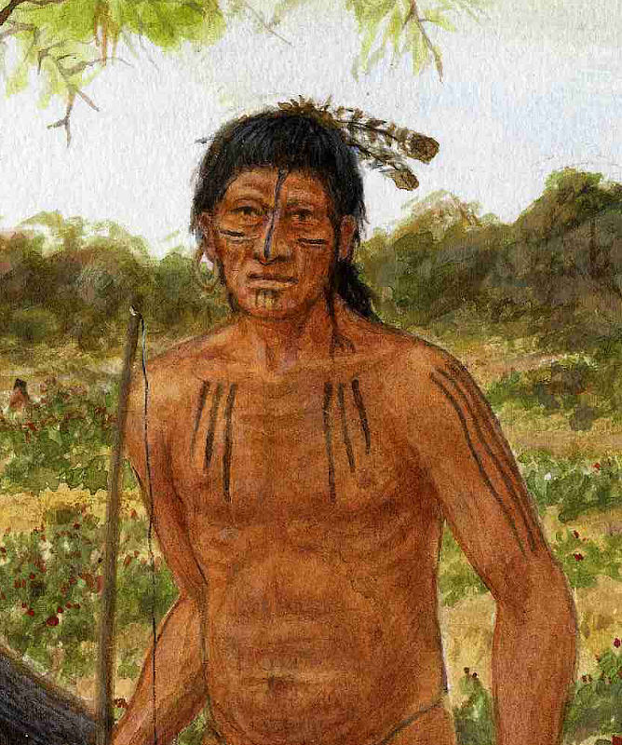
Wickiup shelter framing Coahuiltecan man

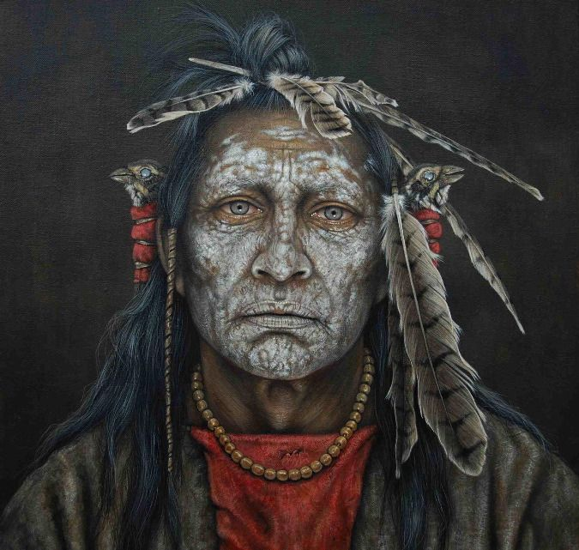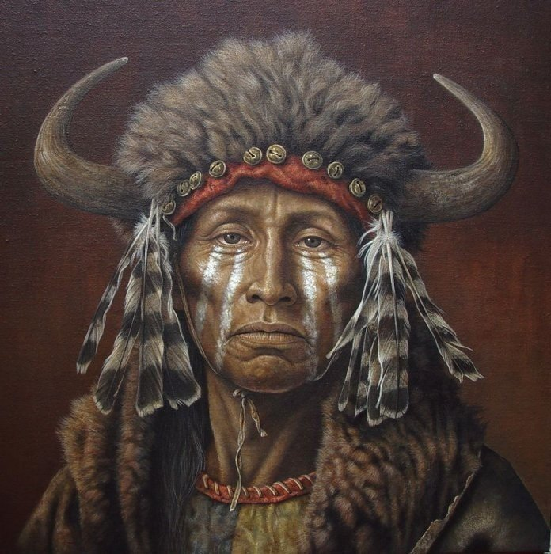
SHAMANS had many roles...
Medicine Men | Spirit Travelers | Tribal Leaders

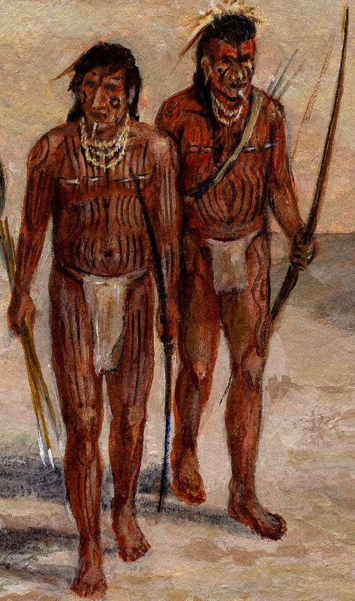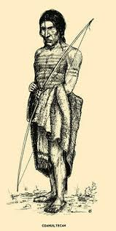

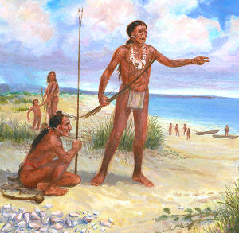
KARANKAWA INDIANS
The Karankawa did not need much clothing.
Their clothes were made out of deerskin or grass.
They painted themselves with bright colors.

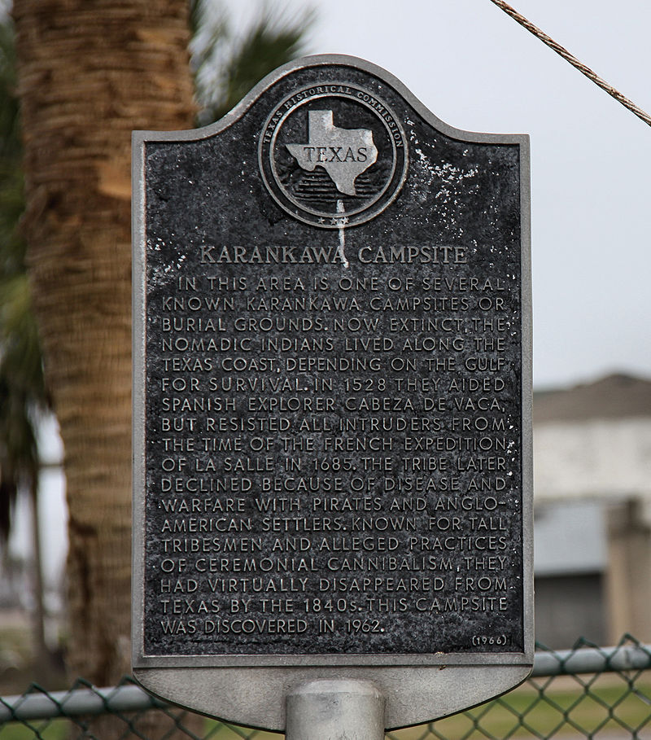
KARANKAWA CAMPSITE
Texas Historical Marker (1966)

