IMAGES | The Southeastern Peoples
Caddo | Atakapa | Wichita

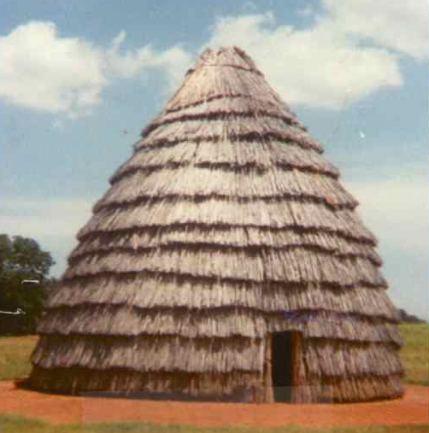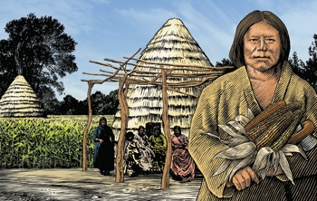
Wickiup (Permanent Home) Caddo with Corn in front of Wickiup

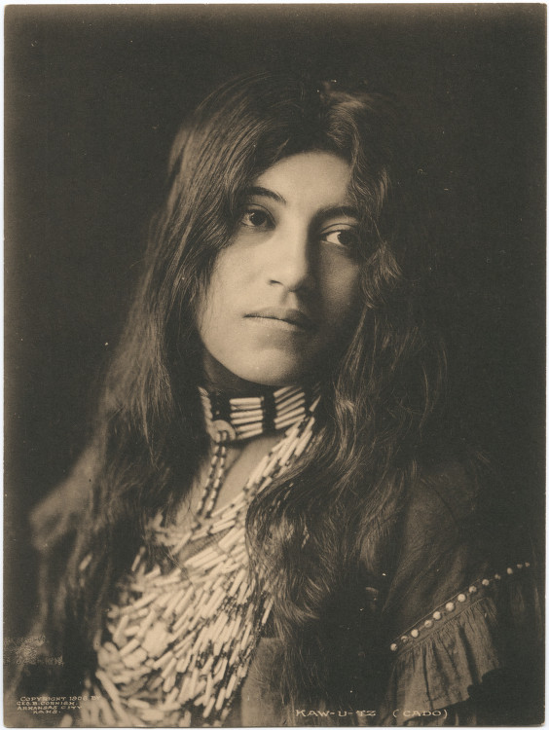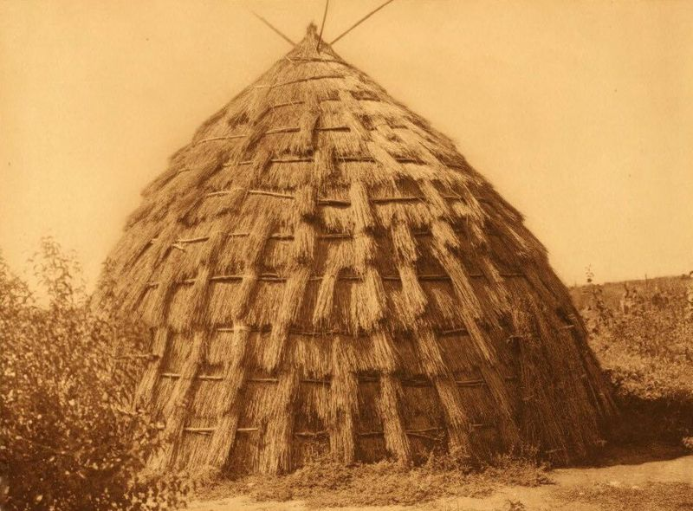
Caddo woman (Kaw-u-tz, 1906 photo) Wichita Grass House (Permanent Home)

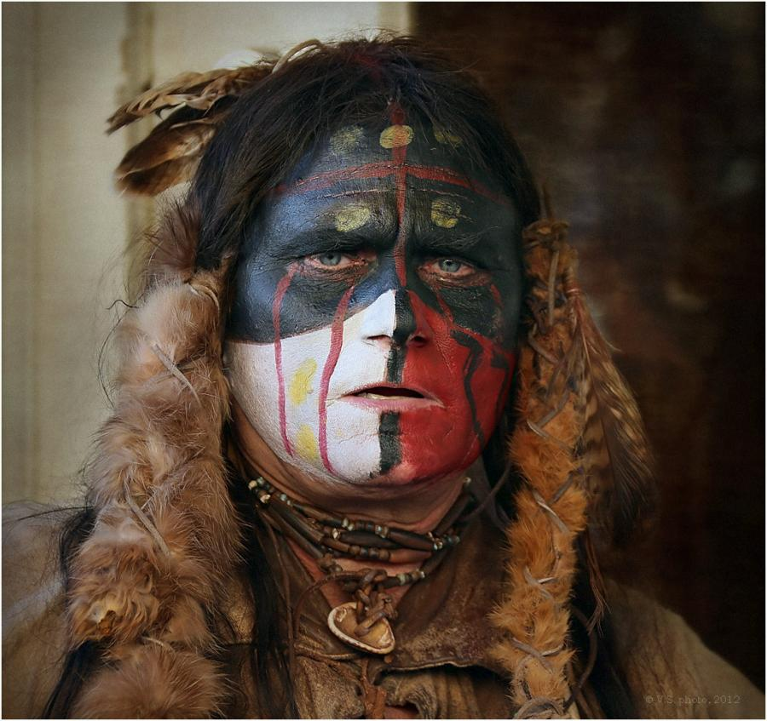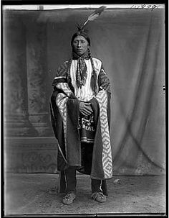
Man of the Wichita Tribe Wichita Chief (1904 photo)

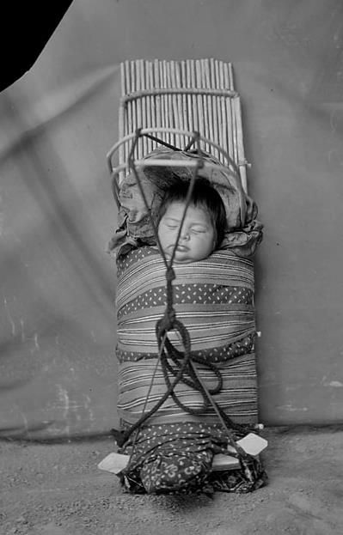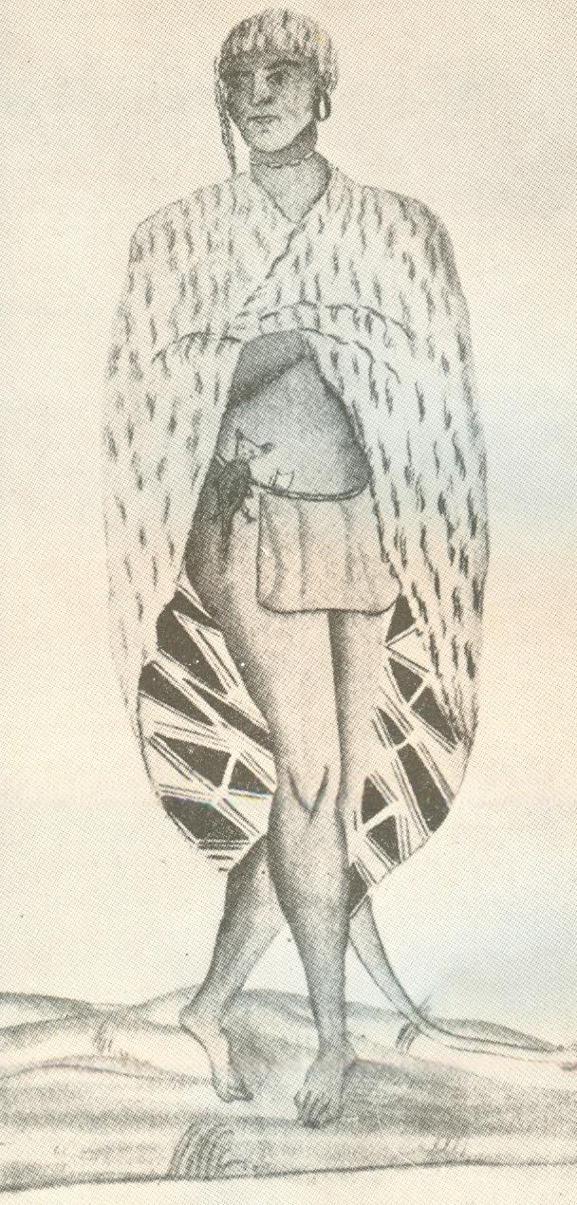
Wichita baby in handmade carrier (photo) An Atakapa Indian in his winter clothing (1735)

