IMAGES | The Puebloan Peoples
Jumano | Concho | Tigua

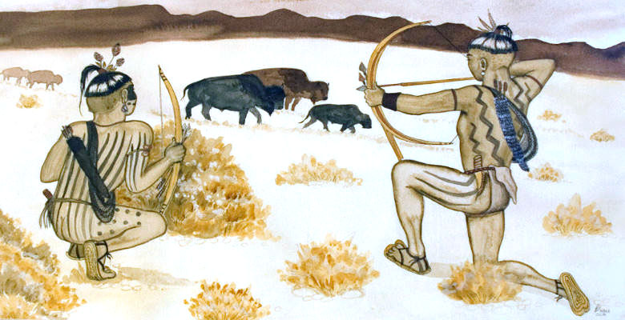
Jumano Indians hunting bison (buffalo)

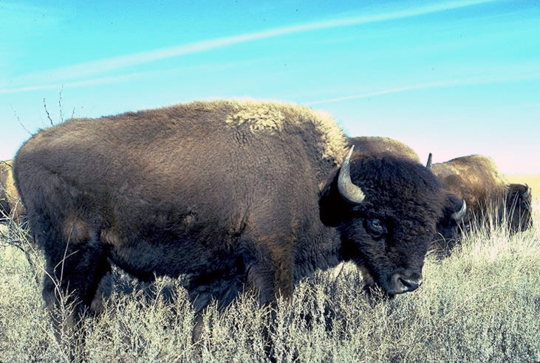
Bison (buffalo)

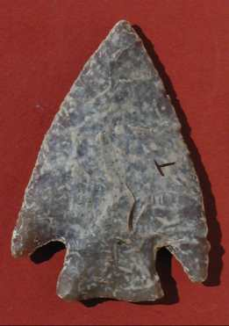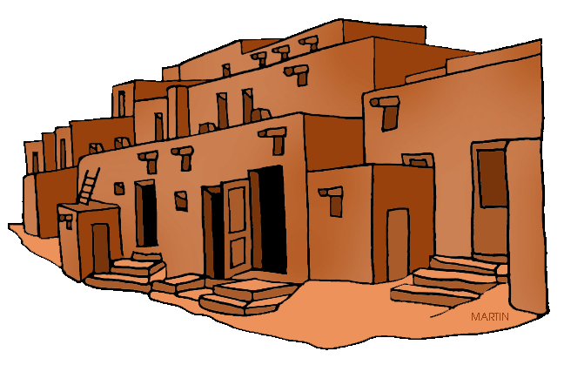
Arrowhead (for bow & arrow) Adobe Pueblos (permanent homes)
[or Spearhead (for spear)]

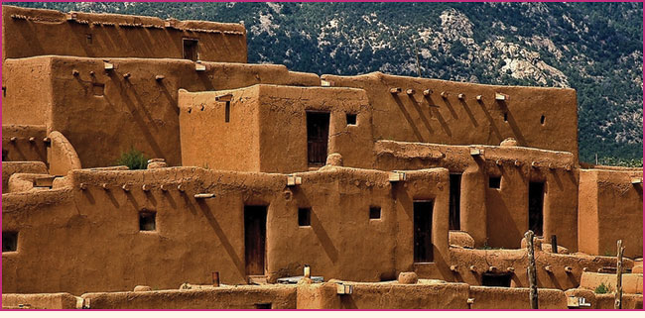
Adobe Pueblos (permanent homes)

