IMAGES | The Plains Peoples
Tonkawa | Lipan Apache | Comanche | Kiowa

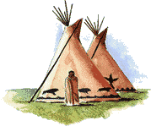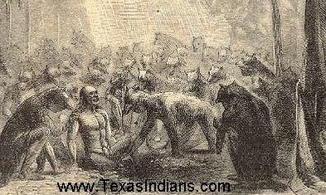
Tipi (Plains People shelter) Tonkawa Wolf Dance (religious ceremony)

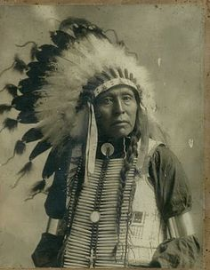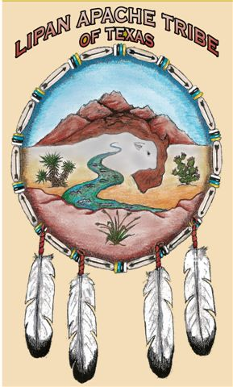
Comanche Chief Lipan Apache Tribe Shield (MORE INFO)
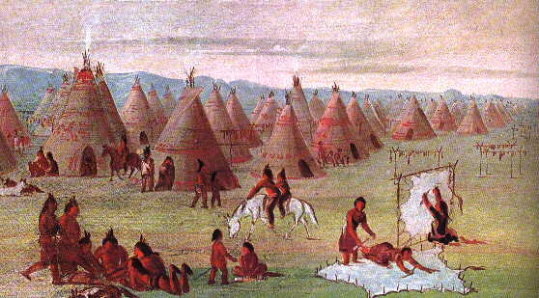
Comanche Village (collection of tipis / tanning buffalo hides) (George Catlin, 1834)

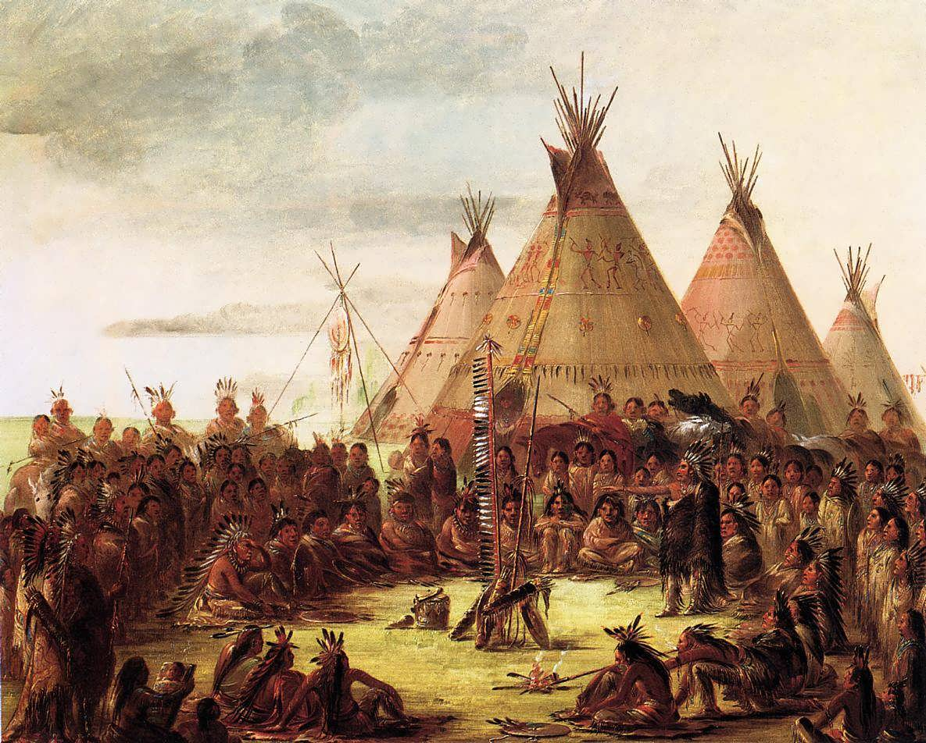
Comanche War Council Meeting (George Catlin, 1834)
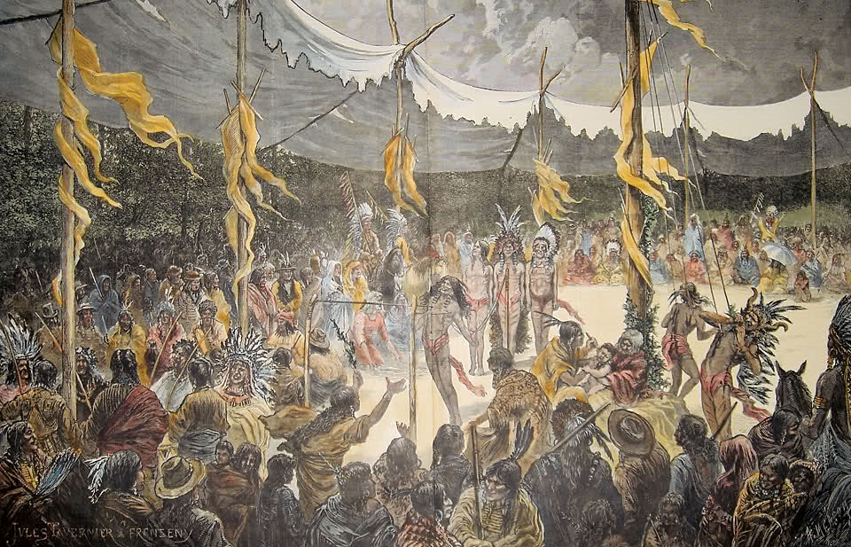
Kiowa Indian Sun Dance
A public and dramatic annual American Indian religious ceremony held before the summer bison hunt,
the Sun Dance spread across the Great Plains sometime after 1800. (MORE INFO)

