Name: _____________________________________________________________________ Period: ____ January 2017 SLMS | Baxmann

--PROJECT | Republic H.S. Report Card--

INSTRUCTIONS: The following IMAGES can be used on your Project. Please use CAPTIONS to inform your audience.

REPUBLIC OF TEXAS FLAG (1836-1839)

REPUBLIC OF TEXAS FLAG (1839-1845)

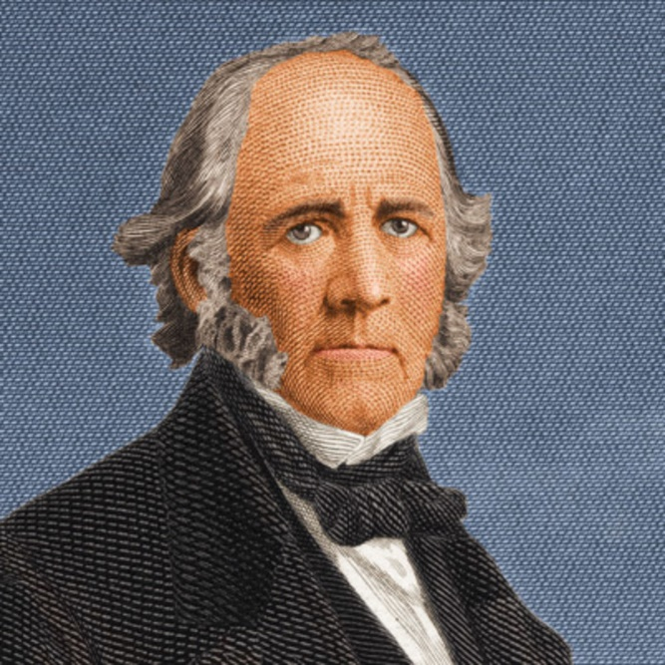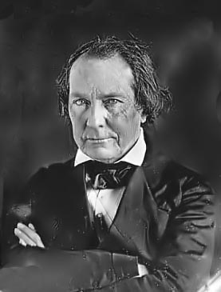
SAM HOUSTON (1836-1838) (1841-1844) MIRABEAU B. LAMAR (1838-1841)

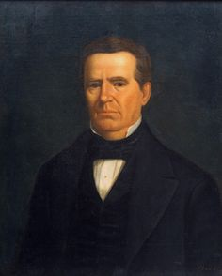
ANSON JONES (1844-1846)

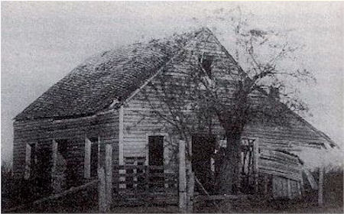
FIRST REPUBLIC OF TEXAS CAPITAL AT COLUMBIA (c. 1900)

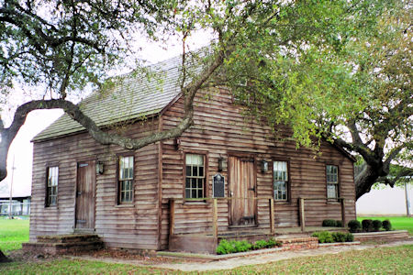
FIRST REPUBLIC OF TEXAS CAPITAL AT COLUMBIA (REPLICA)

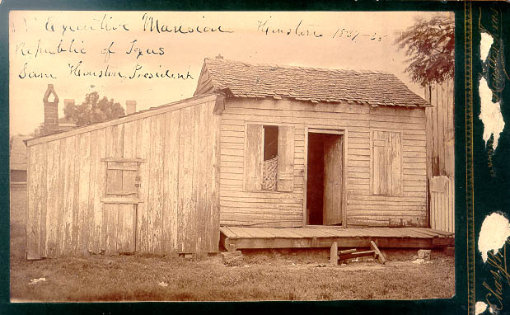
SECOND REPUBLIC OF TEXAS CAPITAL—EXECUTIVE MANSION—AT HOUSTON

SEAL OF THE REPUBLIC OF TEXAS
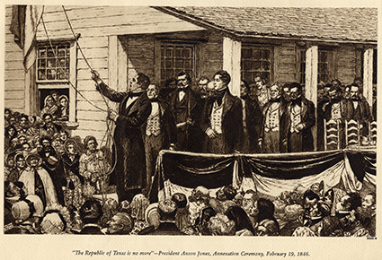
ANNEXATION CEREMONY—TRANSFER FROM REPUBLIC TO STATEHOOD—FEBRUARY 1846

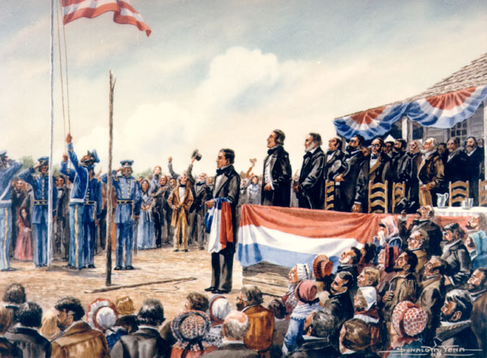
ANNEXATION CEREMONY—TRANSFER FROM REPUBLIC TO STATEHOOD—FEBRUARY 1846
SIGNATURE—SAM HOUSTON

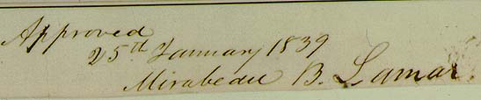
SIGNATURE—MIRABEAU B. LAMAR

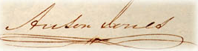
SIGNATURE—ANSON JONES

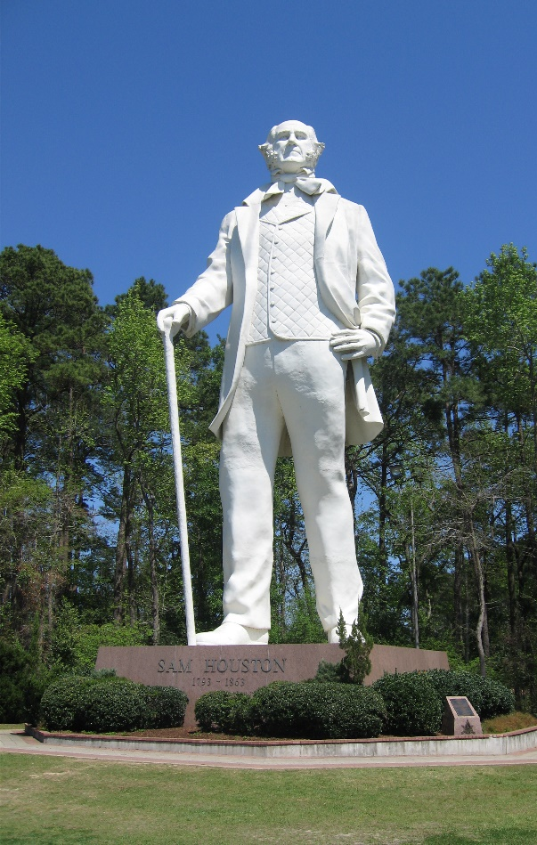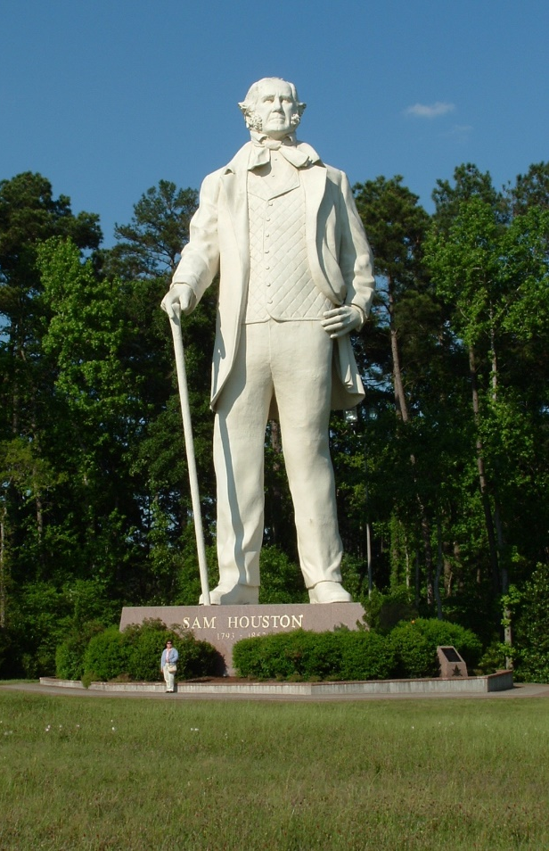
STATUE OF SAM HOUSTON—HUNTSVILLE
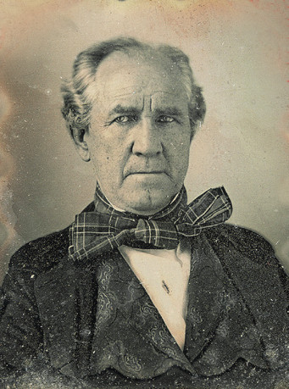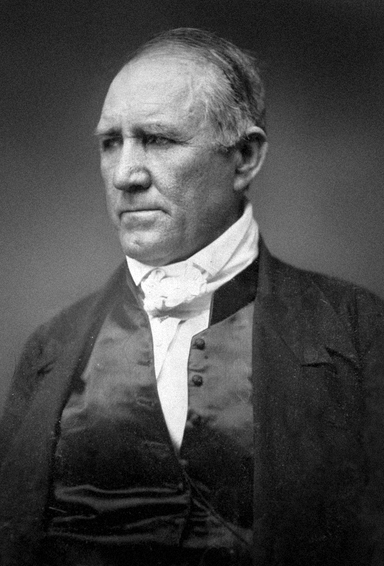
SAM HOUSTON (PHOTO, c. 1850) SAM HOUSTON (PHOTO, c. 1856)

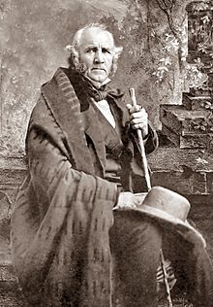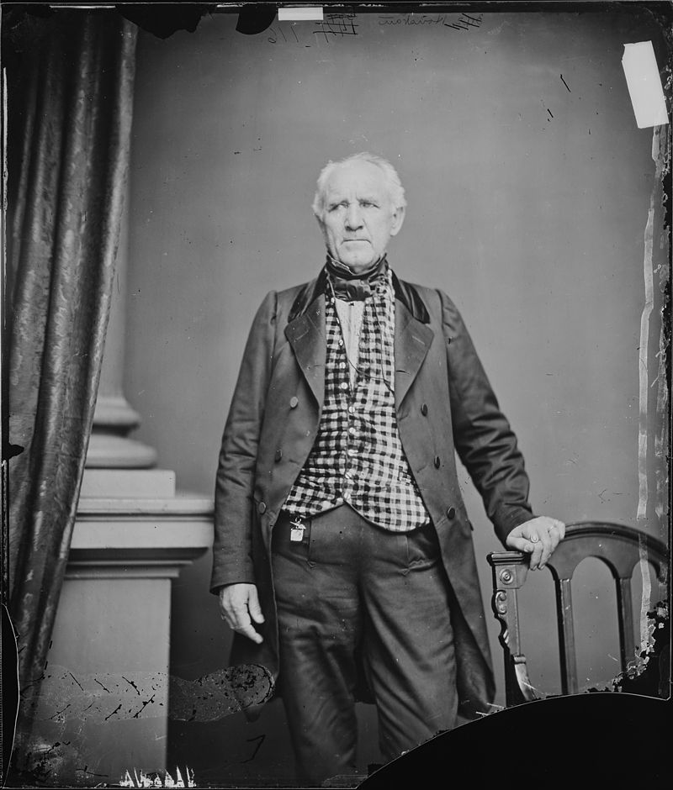
SAM HOUSTON (PHOTO, c. 1861) SAM HOUSTON (PHOTO, c. 1863)

